Analisis Tipologi Kutipan

Tema 1: Revival Memory - Representasi Trend Y2K dalam Media Online
Tabel 1: Kutipan Verbatim - Revival Memory
No | Nama Media | Tanggal | Kutipan Verbatim
1 | Harper's Bazar | 19 Juli 2025 | For her Lollapalooza Paris performance, Rodrigo continued her streak of blending edgy rock aesthetics with soft, feminine, Y2K-inspired pieces
2 | teen VOGUE | 2025-09-23 00:00:00 | The Ara Top, which everyone online seems to be obsessed with, also features a built-in scarf detail, flutter sleeves, and, to add to the peekaboo effect, a keyhole center that extends to the bodice with button-up detailing
3 | AOL | 19 Juli 2025 | "Hearst Magazines and Yahoo may earn commission or revenue on some items through these links
4 | Marie Claire | 2024-11-16 00:00:00 | Olivia Rodrigo doesn't mind one bit if you can see her underwear
5 | Near | 26 Februari 2025 | Affinity for Nostalgia  If you’re a millennial who has felt a connection to Olivia Rodrigo’s music because of how much it reminds you of what you listened to growing up, then you’re not alone
6 | Yahoo Entertainment | 25 Mei 2024 | Le Specs Work It Sunglasses  Rodrigo has become synonymous with nostalgic dressing, especially when it comes to '90s and early 2000s fashion—and her wardrobe on the GUTS tour, for the most part, has been no different
7 | Yahoo Entertainment | 25 Mei 2024 | Le Specs Work It Sunglasses  Rodrigo has become synonymous with nostalgic dressing, especially when it comes to '90s and early 2000s fashion—and her wardrobe on the GUTS tour, for the most part, has been no different
8 | Yahoo Entertainment | 2024-11-16 00:00:00 | Olivia Rodrigo doesn't mind one bit if you can see her underwear
9 | Yahoo Life | 2024-04-11 00:00:00 | Low-waisted pants have been a huge trend recently, so long shirts were also overdue for a comeback
10 | New York Times | 25 Oktober 2025 | But I’m not trying to nostalgia farm and wax poetic, I swear
11 | Medium | 14 Desember 2024 | Cycle Accelerator 1: The COVID-19 Pandemic  The COVID-19 pandemic played a significant role in accelerating the return of 2000s trends, as many people sought comfort in nostalgia during a time of uncertainty and isolation
12 | The Science Survey | 10 Juli 2024 | With 1
13 | Palmetto & Pine | 7 Oktober 2025 | Music is also part of the comeback
14 | Palmetto & Pine | 7 Oktober 2025 | Chunky sneakers, cropped tops, and shiny accessories are so back
15 | Palmetto & Pine | 7 Oktober 2025 | Chunky sneakers, cropped tops, and shiny accessories are so back
16 | The Lamron | 2025-04-11 00:00:00 | Rodrigo’s pop career began with the release of her debut single, “Driver’s License,” when she was just 17 years old
17 | Medium | 2025-09-25 00:00:00 | Fashion has always been cyclical, but few trends have made a comeback as powerful as Y2K
18 | Young Hollywood | 25 Mei 2025 | You head out the door, rocking low-rise jeans, a baby tee with a bold statement, a trucker hat, or a velour sweatsuit
19 | RTE | 2024-04-08 00:00:00 | Opinion: Nostalgia for early 2000s' pop and fashion may paint a rosy picture, but it ignores the complex and contradictory realities of that era  It's clear that nostalgia for the 2000s is significantly shaping major trends in contemporary culture, leaving a lasting impact on society as a whole
20 | RTE | 2024-04-08 00:00:00 | Opinion: Nostalgia for early 2000s' pop and fashion may paint a rosy picture, but it ignores the complex and contradictory realities of that era  It's clear that nostalgia for the 2000s is significantly shaping major trends in contemporary culture, leaving a lasting impact on society as a whole
21 | L'Officiel | 2024-04-17 00:00:00 | Nostalgia rules the fashion cycle but each generation is different; while Millennials hang onto '90s trends, Gen Z finds comfort in the not-too-distant styles of the early 2000s
22 | Cosmopolitan | 9 Juni 2025 | As the temps start rising into a blistering summer heat and our speakers turn up a few decibels, that can only mean one thing: festival season is officially upon us
23 | Pop Sugar | 10 Juni 2024 | Nothing stokes a wave of Y2K nostalgia quite like a trip down Olivia Rodrigo's discography, but it's her accompanying hairstyles that are the retro exclamation point
24 | Pop Sugar | 10 Juni 2024 | Nothing stokes a wave of Y2K nostalgia quite like a trip down Olivia Rodrigo's discography, but it's her accompanying hairstyles that are the retro exclamation point
25 | Yahoo Entertainment | 3 Februari 2025 | Olivia Rodrigo took the Y2K revival to another level at the Grammys 2025
26 | Yahoo Life | 28 Mei 2024 | Sponsored content
27 | Jumlah Kutipan yang presisi |  | 37
28 | Jumlah Kutipan yang presisi |  | 29
29 | Jumlah Kutipan yang presisi |  | 8
30 | Jumlah Kutipan yang presisi |  | 18

Tema 2: Identitas Gen Z - Figur Selebriti Olivia Rodrigo Dalam Trend Y2K
Tabel 2: Kutipan Verbatim - Identitas Gen Z
No | Nama Media | Tanggal | Kutipan Verbatim
1 | Prestige | 2024-11-21 00:00:00 | The Gen Z pop phenomenon Many Grammy Awards, a sold-out global tour, and singles like “Drivers License” that have broken many Spotify records are just a few of Olivia Rodrigo’s accomplishments
2 | The Orbit | 28 Maret 2025 | We've all heard it: Gen Z is the social media generation, the trendsetters, the ones shaking up the status quo
3 | Palmetto & Pine | 7 Oktober 2025 | Chunky sneakers, cropped tops, and shiny accessories are so back
4 | L'Officiel | 2024-04-17 00:00:00 | Nostalgia rules the fashion cycle but each generation is different; while Millennials hang onto '90s trends, Gen Z finds comfort in the not-too-distant styles of the early 2000s
5 | Jumlah Kutipan yang presisi |  | 38

Visualisasi Word Cloud
Word Cloud 1: Revival Memory
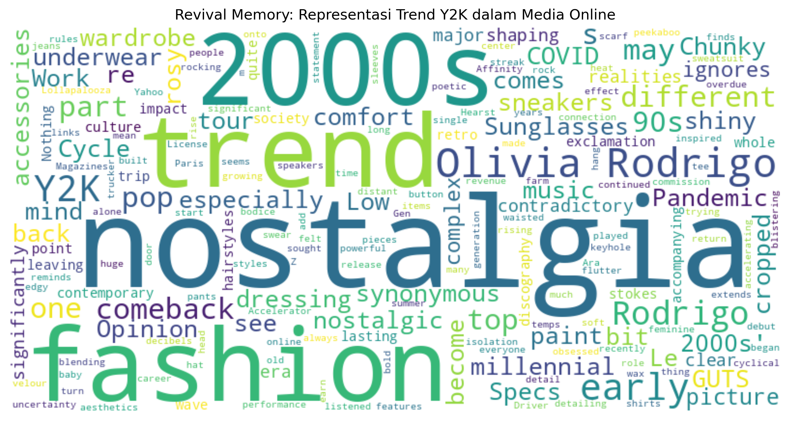
Word Cloud 2: Identitas Gen Z
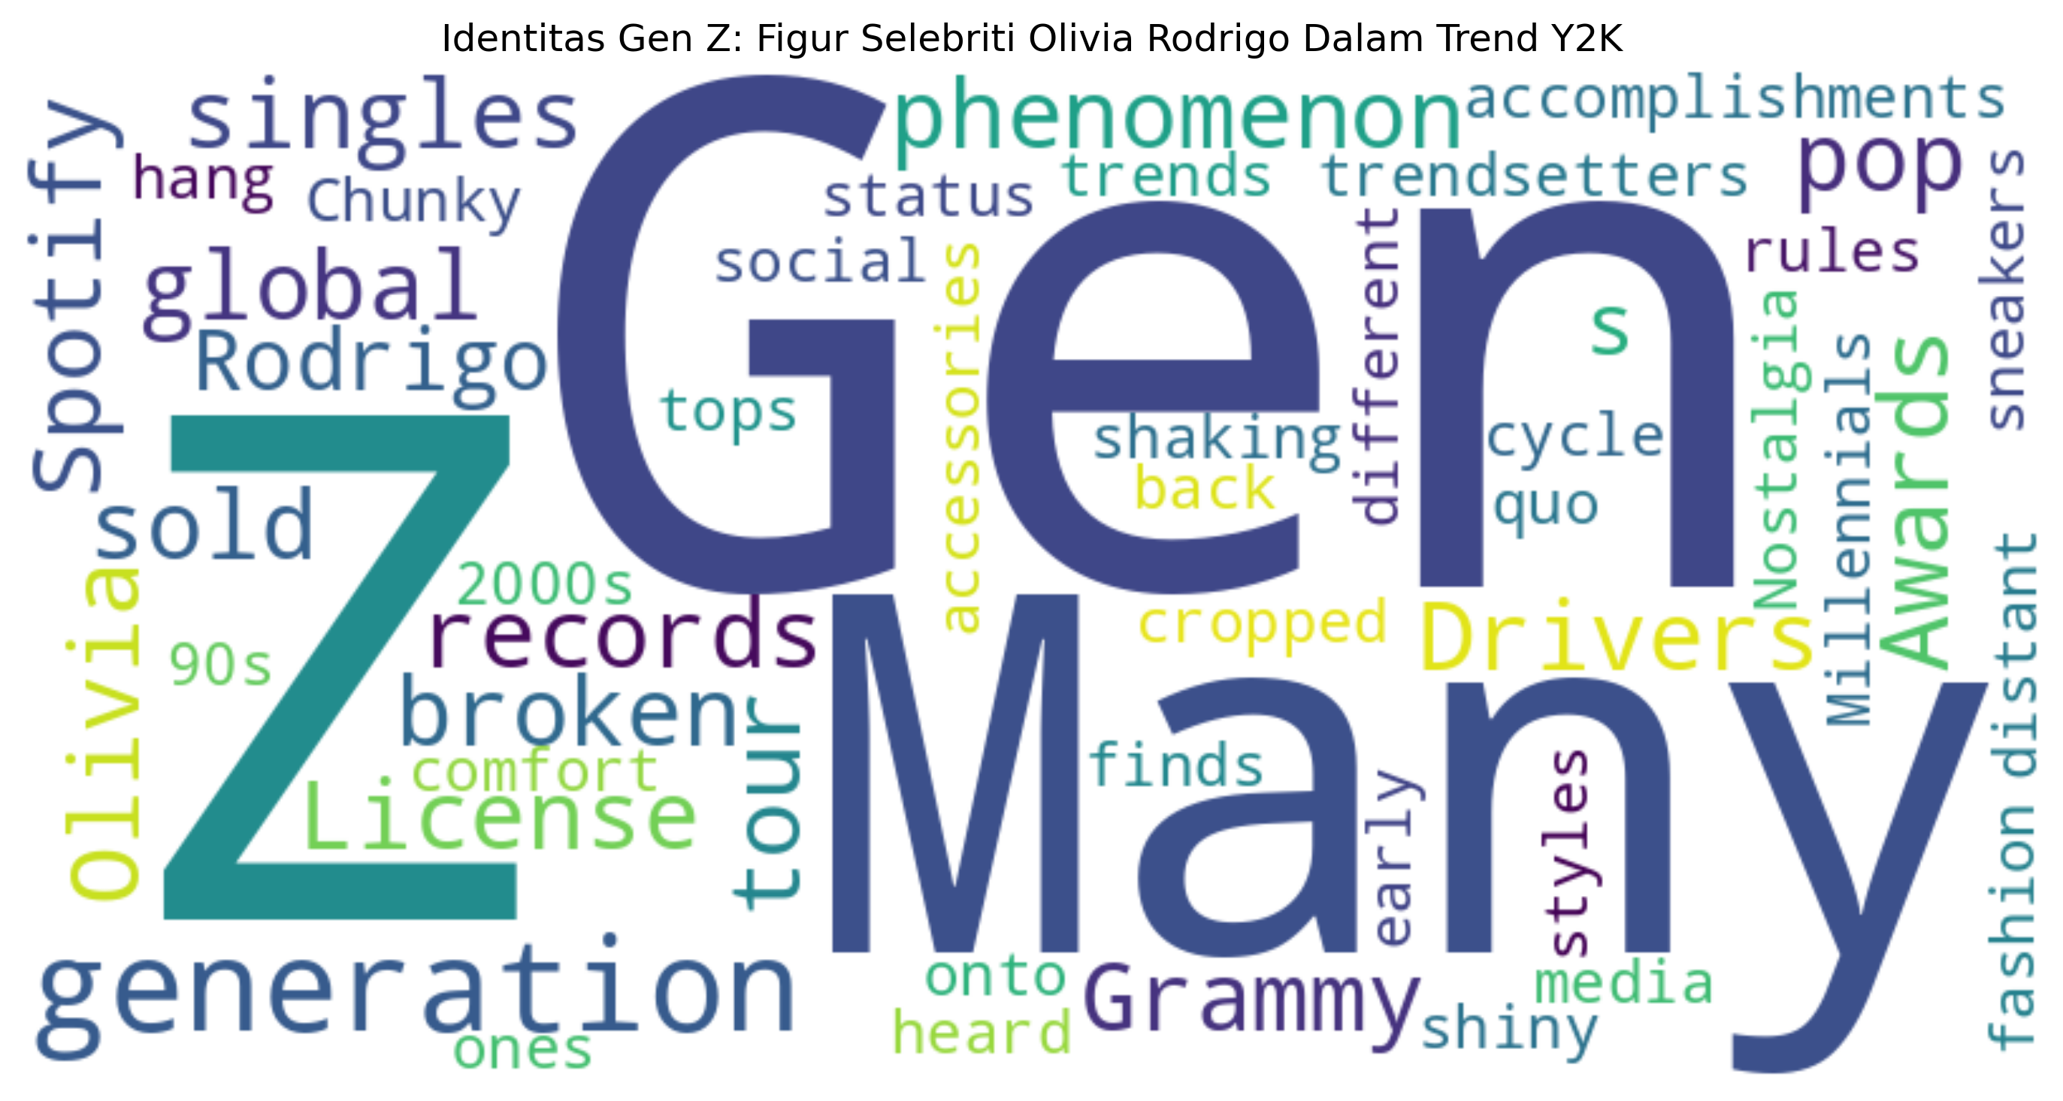

Kesimpulan
Ringkasan Analisis:
1. Tema Revival Memory (Nostalgic, Vintage, Retro, Revival):
- Total kutipan: 30
- Jumlah media: 18
2. Tema Identitas Gen Z:
- Total kutipan: 5
- Jumlah media: 5
3. Total keseluruhan:
- Total media unik yang dianalisis: 20
- Total kutipan: 35

